**Assignment MT1-2019-2**

**Section =1**

(Based on lecture notes)

**1.1)** Derive the equation of continuity in terms of molar flux.

**1.2)** Considering the steady state diffusion in binary gas mixture derive the equation for the flux for the following cases

**a.** Diffusion of A through Non diffusing B

**b.** Equimolar counter diffusion

**c.** Non-Equimolar counter diffusion

C(s) +O2==🡺2CO

**1.3)** Considering the steady state diffusion in binary liquid mixture derive the equation for the flux for the following cases

1. Diffusion of A through Non diffusing B
2. Equimolar counter diffusion
3. Non-Equimolar counter diffusion , When, NA=NB/2

**1.4)** Show the analogies among Mass , Heat & Momentum transfer.

**Section-2**

**(Based on the work out problems in the text book)**

**From book: Principle of mass transfer by B.K.Dutta**

**Ex.2.2 Page no.16**

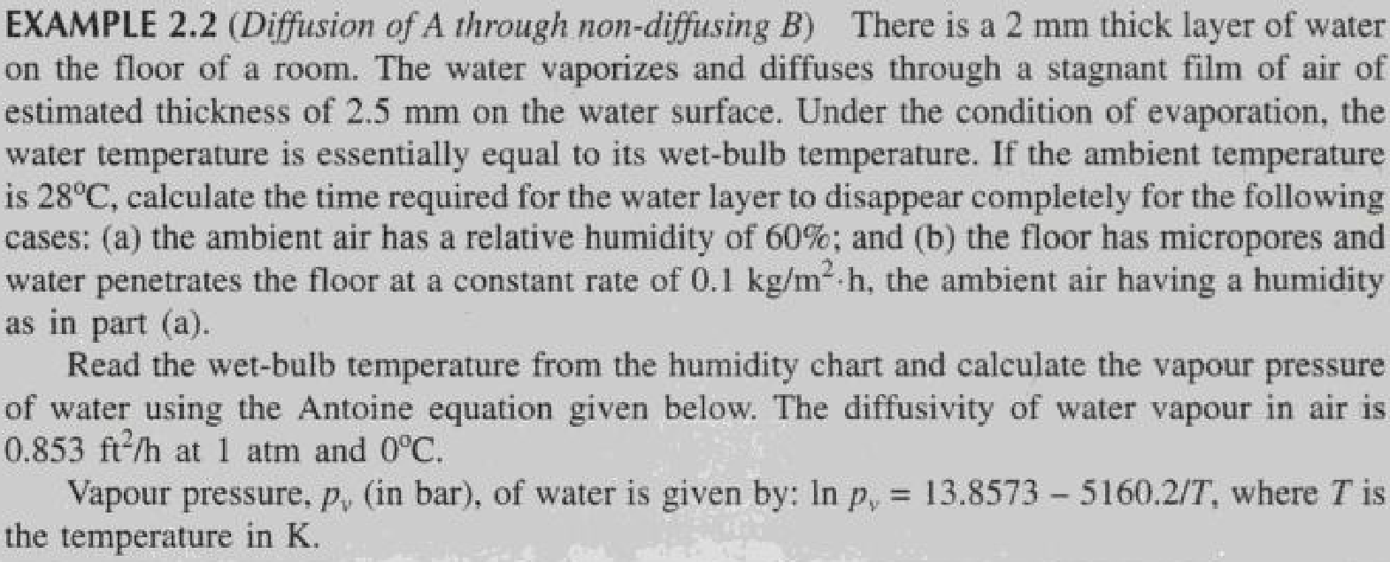

**Ex.2.3 page no.18**

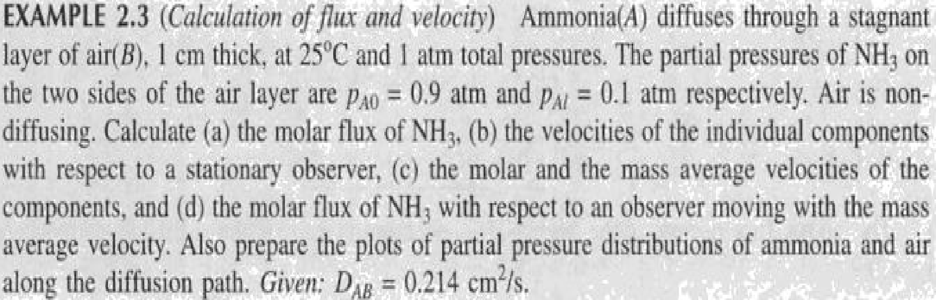

**Ex.2.4 page no .21**

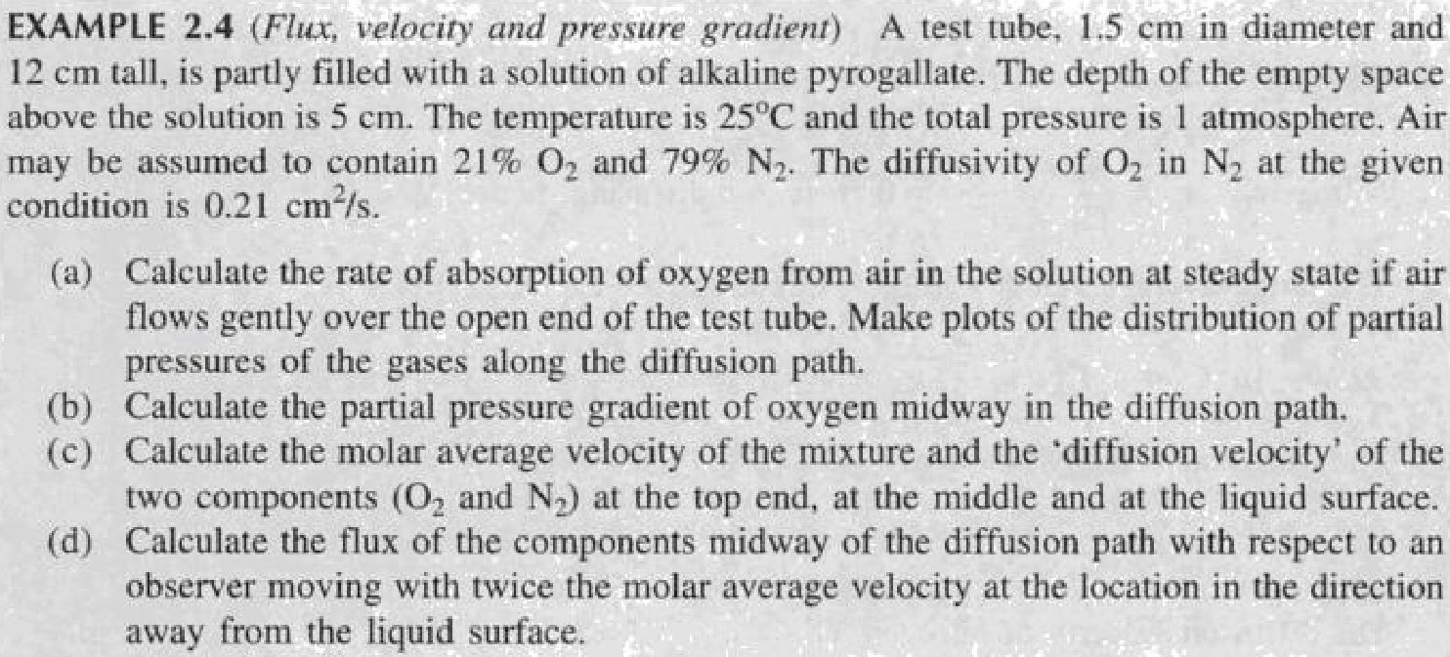

**Ex.2.6 page no.24**

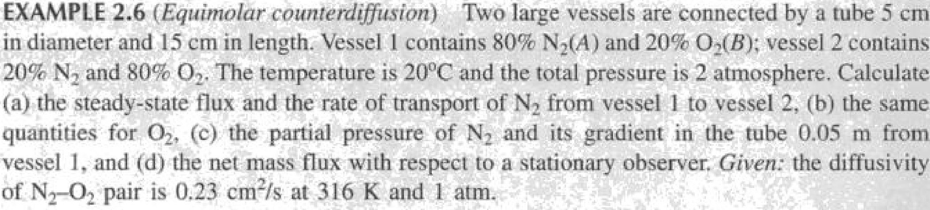

**Ex.2.7 Page no .25**

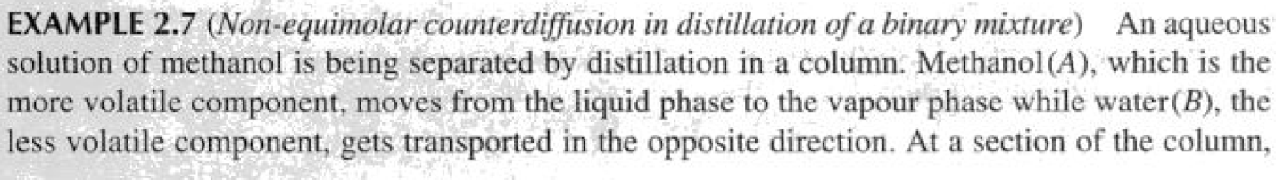

**Ex.2.19 page no 58**



**Section=3**

**(Unsolved problems)**

**3.1)** Microelectronic devices are fabricated by forming many layers of thin films onto a silicon wafer. Each film has unique chemical and electrical properties. For example, a thin film of solid silicon (Si) serves as a semiconductor. Silicon thin films are commonly formed by the chemical vapor deposition, or CVD, of silane vapor (SiH4) onto the surface of the wafer. The chemical reaction is

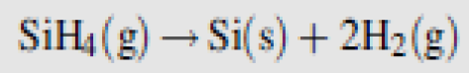

This surface reaction is usually carried out at very low pressure (100 Pa) and high temperature (900 K). In many CVD reactors, the gas phase over the Si film is not mixed. Furthermore, at high temperatures, the surface reaction is very rapid. Consequently, the molecular diffusion of the SiH4 vapor to the surface often controls the rate of Si film formation. Consider the very simplified CVD reactor shown in Figure .A mixture of silane and hydrogen gas flows into the reactor. A diffuser provides a quiescent gas space over the growing Si film. Develop a differential model for this process, including statements of assumptions and boundary conditions.

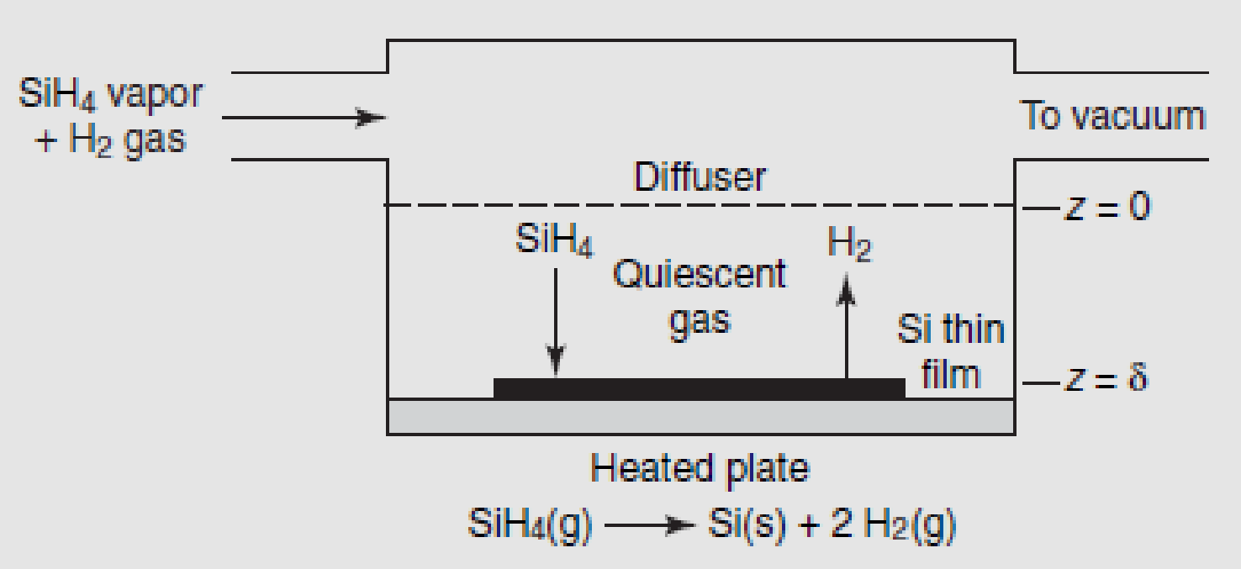

**3.2)** Vapor degreasers like the one shown in Figure are widely used for cleaning metal parts. Liquid solvent rests at the bottom of the degreaser tank. A heating coil immersed in the solvent vaporizes a small portion of the solvent and maintains a constant temperature, so that the solvent exerts a constant vapor pressure. The cold parts to be cleaned are suspended in the solvent vapor zone where the concentration of solvent vapors is highest. The solvent condenses on the part, dissolves the grease, and then drips back down into the tank, thereby cleaning the part. Vapor degreasers are often left open to the atmosphere for ease of dipping and removing parts and because covering them might release an

explosive mixture. When the degreaser is not in use, molecular diffusion of the solvent vapor through the stagnant air inside the headspace can result in significant solvent emissions, because the surrounding atmosphere serves as an infinite sink for the mass-transfer process. As the amount of solvent in the degreaser tank is large relative to the amount of vapor emitted, a steady-state diffusion process with a constant diffusion path length takes place.

At present, a cylindrical degreaser tank with a diameter of 2 m and total height of 5 m is in operation, and the solvent level height is kept constant at 0.2 m. The temperatures of the solvent and headspace of the degreaser are both constant at 350C. The solvent used for vapor degreasing is trichloroethylene (TCE). Current regulations require that the degreaser cannot emit more than 1.0 kg TCE per day. Does the estimated emission rate of the degreaser exceed this limit? TCE has a

molecular weight of 131.4 g/mol and a vapor pressure of 115.5 mmHg at 350C. The binary-diffusion coefficient TCE in air is 0.088 cm2/s at 350C, as determined by the Fuller–Schettler–Giddings correlation.

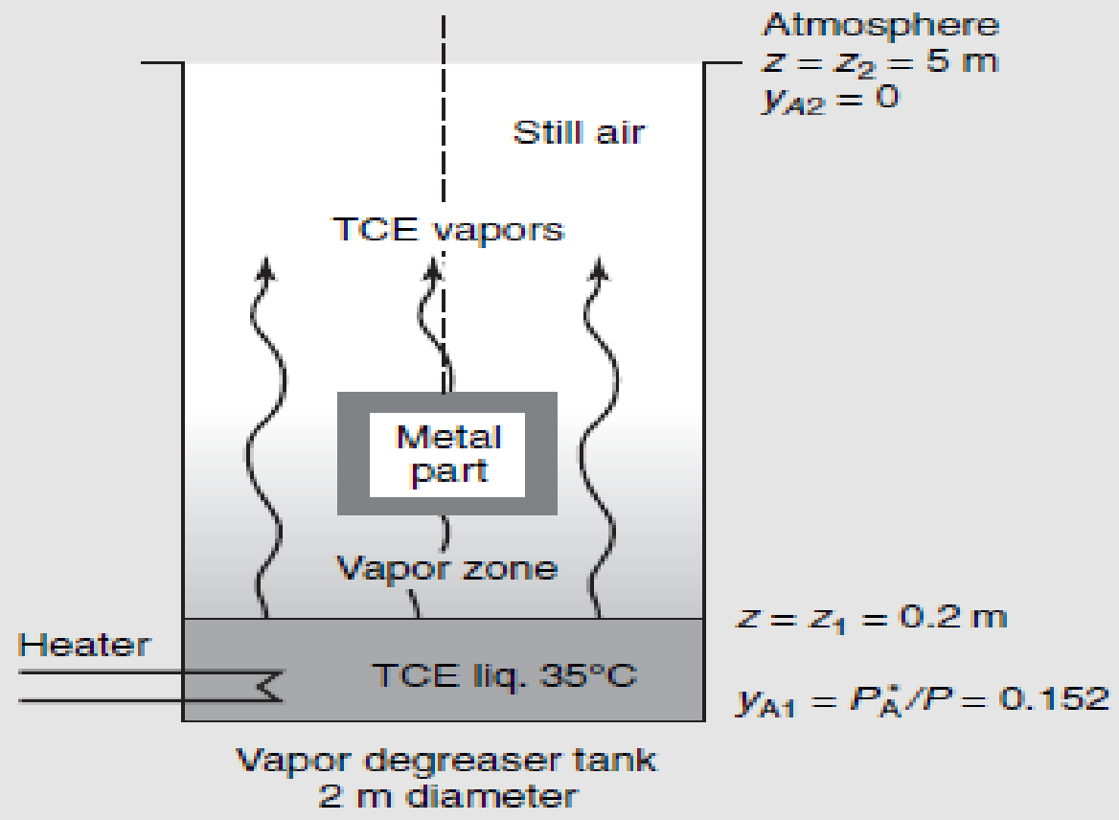

**3.3)** The moisture in hot, humid, stagnant air surrounding a cold-water pipeline continually diffuses to the cold surface where it condenses. The condensed water forms a liquid film around the pipe, and then continuously drops off the pipe to the ground below. At a distance of 10cm from the surface of the pipe, the moisture content of the air is constant. Close to the pipe, the moisture content approaches the vapor pressure of water evaluated at the temperature of the pipe.

**a.** Draw a picture of the physical system, select the coordinate system that best describes the transfer process and state at least five reasonable assumptions of the mass-transfer aspects of the water condensation process.

**b.** What is the simplified form of the general differential equation for mass transfer in terms of the flux of water vapor, NA?

**c.** What is the simplified differential form of Fick’s equation for water vapor, NA?

**d.** What is the simplified form of the general differential equation for mass transfer in terms of the concentration of water vapor, CA?

**3.4)** Ethanol is diffusing through a 4-mm stagnant film of water. The ethanol concentrations of the entrance and the existing planes are maintained at 0.1 and 0:02 mol/m3, respectively. If the water film temperature is 283 K, determine the steady-state molar flux of the ethanol and the concentration profile as a function of the position z within the liquid film. Compare these results with a 4-mm stagnant film of air at 283 K and 1 atm at the same entrance and exit ethanol concentrations.

**3.5)** 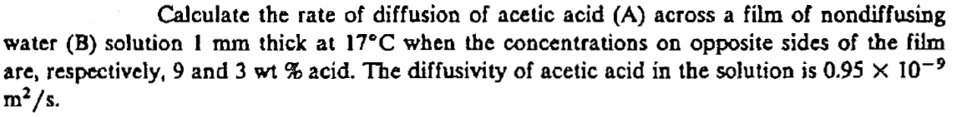

**3.6)** A tube 1 cm in inside diameter that is 20 cm long is filled with CO2 and H2 at a total pressure of 2 atm at 0C. The diffusion coefficient of the CO2 – H2 system under these conditions is 0.275cm2/sec. If the partial pressure of CO2 is 1.5 atm at one end of the tube and 0.5 atm at the other end, find the rate of diffusion for:

1. steady state equimolar counter diffusion (N A = - N B)
2. steady state counter diffusion where N B = -0.75 N A, and
3. steady state diffusion of CO2 through stagnant H2 (NB = 0)